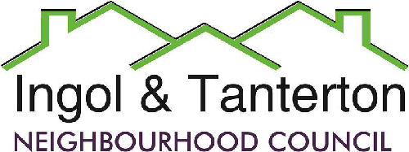

Gill Mason - Clerk and RFO

Email: [ingoltantertonnc@hotmail.co.uk](mailto:ingoltantertonnc@hotmail.co.uk)

**Agenda**

**A meeting of the Ingol and Tanterton Neighbourhood Council Finance & Asset Committee will be held on Monday 6th January 2025 at 7.15pm at Tanterton Village Centre.**

**Open forum**

1.To receive apologies.

2.To approve the minutes of the December Finance Committee Meeting.

3.To review the draft budget for 2025/2026.

Press and public are welcome to attend.